**Server Dashboard**

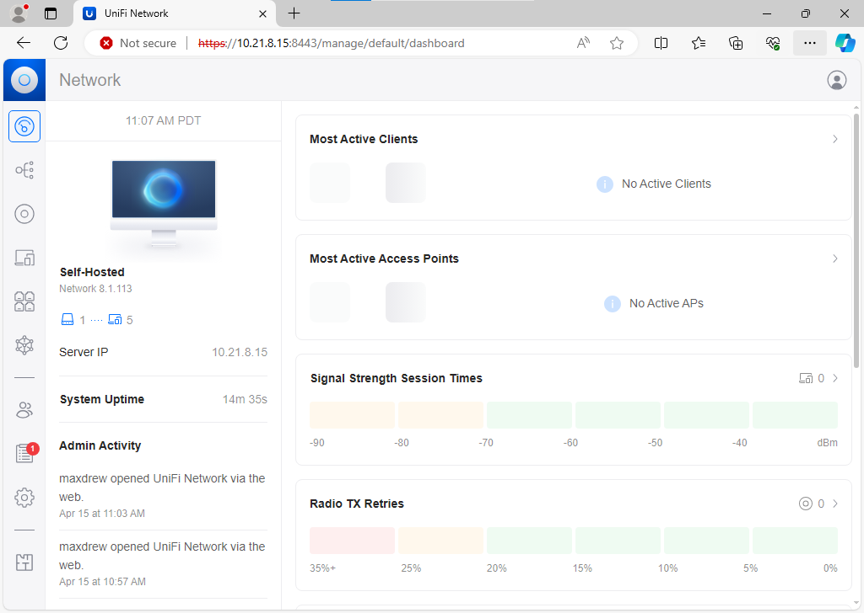

Logged in as the second admin account on the server manager dashboard. Current name is “Self-Hosted.”

**New Account**

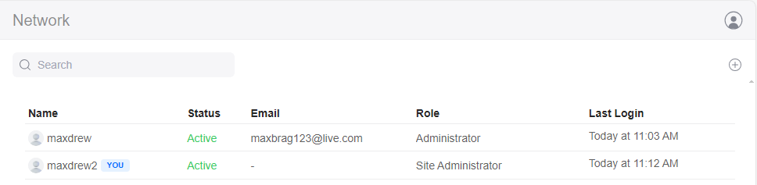

maxdrew added maxdrew2 as a site admin.

**Max’s Change**

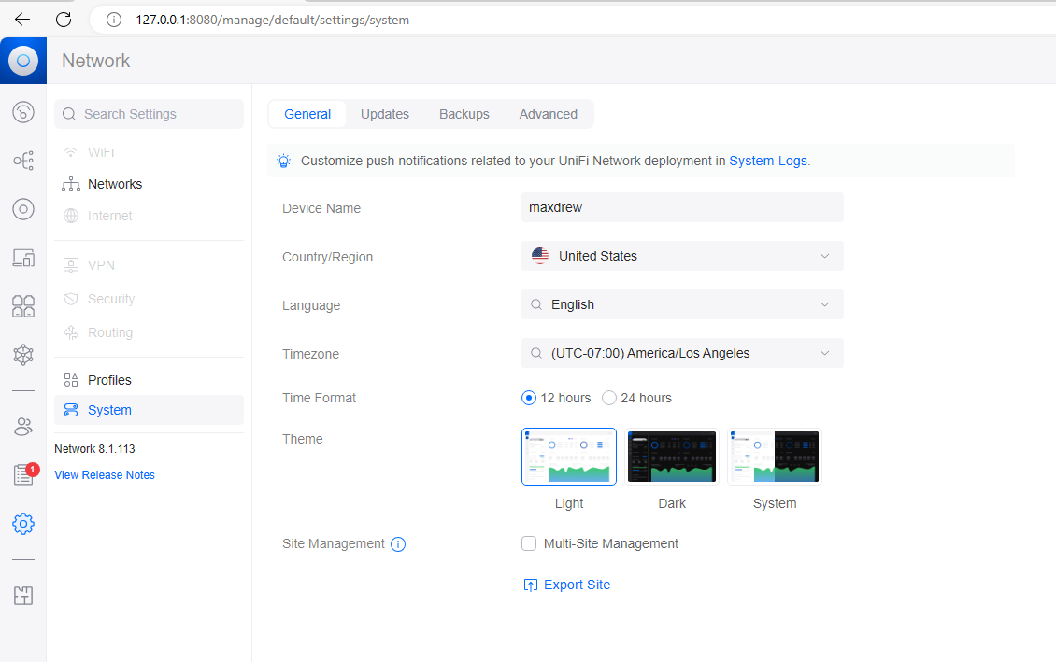

Max changed the name of the switch to “maxdrew”.

**Drew’s Change**

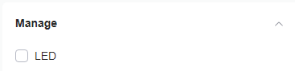

Drew changed the LED indicator light on the switch to off. Now the switch no longer lights that up when on.